20th World Congress of Neurology, Marrakesh, November 12-17, 2011

The city of Marrakech (Morocco) will host the 20th World Congress of Neurology (WCN) on November 12th to 17th, 2011.
The Congress is held under the High Patronage of His Majesty the King Mohamed VI. It will take place at the “Palais des Congrès”, located on a large avenue in the heart of Marrakesh. It is an international center for exhibition, which provides all necessary technical background for organizing a successful meeting, and has already hosted several large medical conferences.
Marrakesh is the first tourist city in Morocco and has more than 150 hotels. Many hotels are located close to the “Palais des Congrès” and are sufficient to accommodate all participants at less than 15 minutes walk. Marrakesh is also well known by his Ryads which are traditional houses and palaces with luxury and modern comfort.

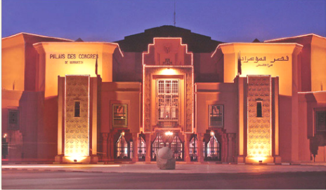
« Palais des Congrès » of Marrakesh

Marrakesh is a wonderful and safe city with a secure environment. It is only three hours by direct flights from many European countries. Other parts of the world are served by flights to Casablanca, which is connected to Africa, Arabic countries, Asia, North and South America. Marrakesh can be easily reached from Casablanca in about two hours by highway, rail or by internal flights. Historically, Marrakesh is the heiress of an original civilization, distinctive by its architecture, traditional crafts, cuisine and the legendary hospitality of its people. Marrakesh is among the sunniest cities of the kingdom. In November, temperatures range between 12ºC at night and 26ºC during the day.
Sidelines of the congress, participants could walk to visit the main monuments of the city and participate in excursions to discover the beautiful landscapes of the region that includes the Oukaïmeden snowy mountains as well as the Atlantic coast.

The congress will be held on 6 days and will begin on Saturday, November 12th. The Scientific Program of the 20th WCN is rich and well underway. It contains 40 topics with 80 sessions. The various scientific sessions will include Teaching Courses, Plenary Sessions, Main Topics, Free Communications, Regional Sessions, Daily Debates (Controversies in Neurology), Sponsored Symposia and the Tournament of the Minds. Exhibition visits and Guided Poster Walks will be organized.
Classical neurological topics will be held such as Epilepsy, Movement Disorders, Stroke, Dementia, Neuro-immunological diseases, Muscles Diseases... and update topics in Neurology, such as neuro-critical care, palliative care, Stem Cells or New Treatments in Neurology. The scientific program highlights the particularities of the practical of neurology in developing countries, like Stroke in the young, diagnostic of cognitive disorders or tropical CNS Infections.

The geographical distribution of speakers is broad since the 295 speakers will come from 54 countries.

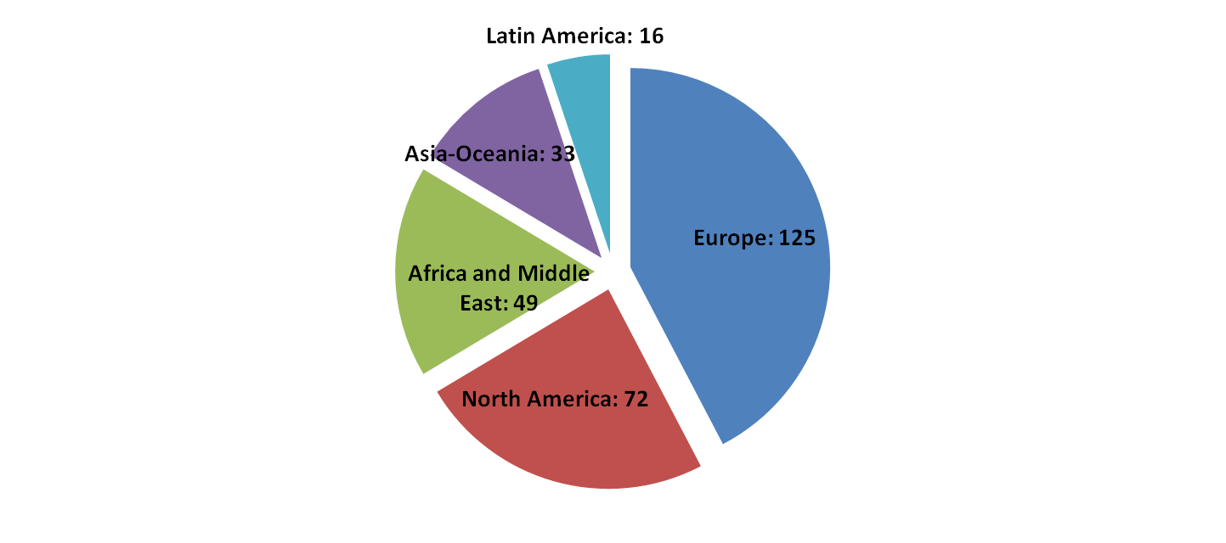

Six Teaching Courses per day, seven Workshops and free educational courses for young neurologists will be organized. Teaching will be provided by acclaimed specialists in various fields of neurology.
There will be 150 free communications on various subjects of Neurology. Participants are invited to submit their abstracts online before the deadline of Wednesday June 15, 2011.

The 4th Tournament of Minds will be held in Marrakesh, as in the 3 past WCN. There will be one team per country, made up of 4 persons, and teams will compete with each other in a knockout competition to answer questions across a range of Neurological topics. Countries who wish to participate are invited to contact the president of their local member society for coordinating a national team.

WCN2011 Scientific Program

Saturday  12th Nov | Sunday  13th Nov | Monday  14th Nov | Tuesday  15th Nov | Wednesday  16th Nov | Thursday  17th Nov
Teaching courses | Teaching courses | Teaching courses | Teaching courses | Teaching courses | Teaching courses
 | Plenary lectures | Plenary lectures | Plenary lectures | Plenary lectures | Plenary lectures
 | Main topics : invited lectures | Main topics : invited lectures | Main topics : invited lectures | Main topics : invited lectures | Main topics : invited lectures
 | Free communication | Free communication | Free communication | Free communication | Free communication
 | Sponsored symposia | Sponsored symposia | Sponsored symposia | Sponsored symposia | Sponsored symposia
 | Regional Session | Regional session | Regional session | Regional session | Regional session
 |  | Daily debates | Daily debates | Daily debates
 |  |  | Tournament of minds | Tournament of minds | Tournament of minds
 | Opening Ceremony |  |  |  | Closing Ceremony

For further information, please visit the congress Website on www.wcn-neurology.org

Professor Mostafa El Alaoui Faris. elalaouifarism@yahoo.fr

President of 20th World Congress of Neurology.

